CRAIG, EDWARD GORDON (1872-1966)

Edward Gordon Craig was one of the leading figures of modernist theatre. His books, stage designs, manifestos, and collaborations all contributed to an understanding of performance as an autonomous aesthetic activity, as a creative event that does not rely soley on the multifaceted transpositions of the literary text, but offers a unique, synaesthetic possibility of combining different art forms. Craig’s work was crucial in conceiving of performance as a live, ephemeral but dynamic event that may derive from a literary text but is never confined to it.

The son of actress Ellen Terry and architect E. W. Godwin, Craig’s early life in England was steeped in theatre. The seeds of his craft and radical thinking were sown during his apprenticeship with his mother and Sir Henry Irving at London’s Lyceum Theatre, while his early productions of the 1890s—Purcell’s Dido and Aeneas and the semi-operatic Masque of Love and Handel’s Acis and Galatea—were influenced by his composer friend Martin Shaw. During the same period and in the spirit of the Arts and Crafts movement, Craig edited a short-lived magazine called The Page (1899) and produced a number of books, all of which experimented with the relationship between text and image but also with the ways the printed page itself could act as a type of stage. These early projects that brought together theatre, opera, and the printed page highlighted his synaesthetic approach—influenced by Wagner’s notion of the Gesamtkunstwerk—an approach that was to be the hallmark of his later experiments in modernist theatre.

Craig’s work can be read as enacting and bridging the crucial shift between the Arts and Crafts movement and modernism, while also creating links between the Anglophone stage traditions of the actor-manager and the continental theatrical experiments that helped shape modernist performance, particularly in the areas of modernist acting and directing. Indeed, Craig’s life itself can be seen as having enacted such a trajectory. He left England for Germany in 1904 and in 1905 produced one of his most influential books, The Art of the Theatre. In 1908 he settled in Florence at the Arena Goldoni and published The Mask (1908-1929), one of first journals to be devoted to theatre as a performance practice. Throughout the many volumes of The Mask, Craig explicated his radical ideas, his deep understanding of theatre history, and his own projects. His notorius essay ‘The Actor and the Übermarionette,’ a re-working of and homage to Heinrich von Kleist’s essay on puppets of c.1810, appeared in The Mask in 1909, and one of his most significant collaborations with Konstantin Stanislavsky, on the Moscow Hamlet (1908-1911), is chronicled in journal’s pages, utilising many of the sixty-five pseudonyms that Craig created for himself.

Craig’s ideas on acting, on the use of screens to conceptualise scenic space, and on lighting and costume took shape through his sometimes difficult collaborations with leading modernist figures like Stanislavsky at the Moscow Art Theatre, dancer Isadora Duncan, and W. B. Yeats at the Abbey Theatre. Although he mounted few productions after the age of about forty, his early books—written with the fervour of the modernist manifesto combined sometimes with philosophical, Platonic dialogue—and his numerous publications of stage designs helped to create and solidify a language for modernist performance that continues to inspire theatre makers and performance theorists today.

List of Works

The Page (1899).
Henry Irving, Ellen Terry: A Book of Portraits (1899).
The Art of the Theatre (1905).
Isadora Duncan: Six Movement Designs (1906).
The Mask (1908-1929).
On the Art of the Theatre (1911).
Towards a New Theatre (1913).
A Living Theatre (1913).
The Marionette (1918).

The Theatre Advancing (1921).
Puppets and Poets (1921).
Scene (1923).
Books and Theatres (1925).
Hamlet (1929).
A Production (1930).
Henry Irving (1930).
Ellen Terry and Her Secret Self (1932).
Index to the Story of my Days (1957).
The Black Figures of Edward Gordon Craig (1988).

References and Further Reading

Craig, Edward.Gordon. (1911, 2008) On the Art of the Theatre, ed. Franc Chamberlain, London: Routledge Theatre Classics.

Innes, Christopher. (1983) Edward Gordon Craig: A Vision of Theatre, London: Routledge.

Rood, Arnold. (1977) Gordon Craig on Movement and Dance, New York: Dance Horizons.

Senelick, Laurence. (1982) Gordon Craig’s Moscow ‘Hamlet’: A Reconstruction, Westport, CT: Greenwood.

Taxidou, Olga. (1998) The Mask: A Periodical Performance by Edward Gordon Craig, London: Routledge.

Walton, J. Michael. (1983) Craig on Theatre, London: Methuen.

Olga Taxidou. University of Edinburgh

Recommended Illustrations [NOTE: The copyright for these will have to be cleared with the estate: Marie J. Taylor (Executor, The Edward Gordon Craig Estate): EGC@blueyonder.co.uk]

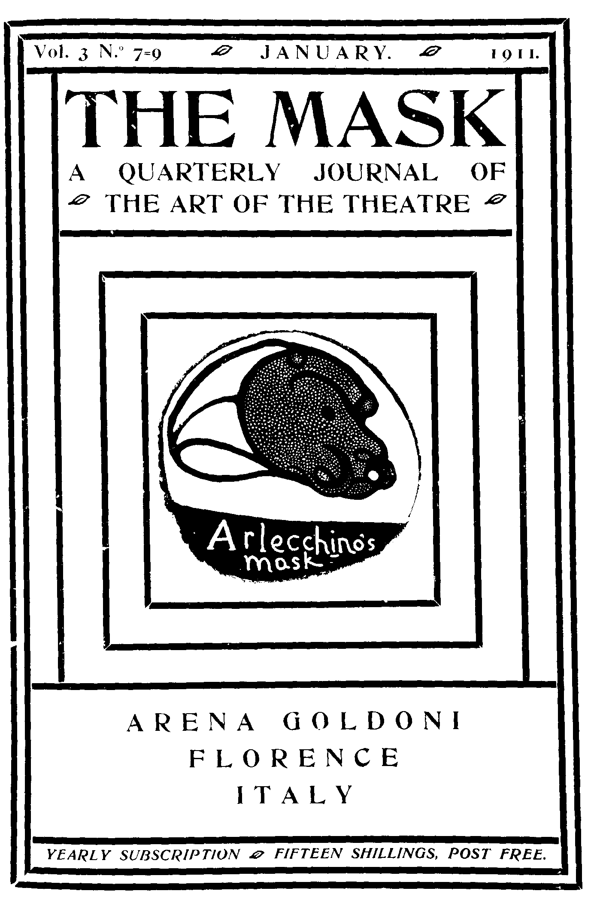

Cover of The Mask, vol. 3, no. 7-9 (1911).

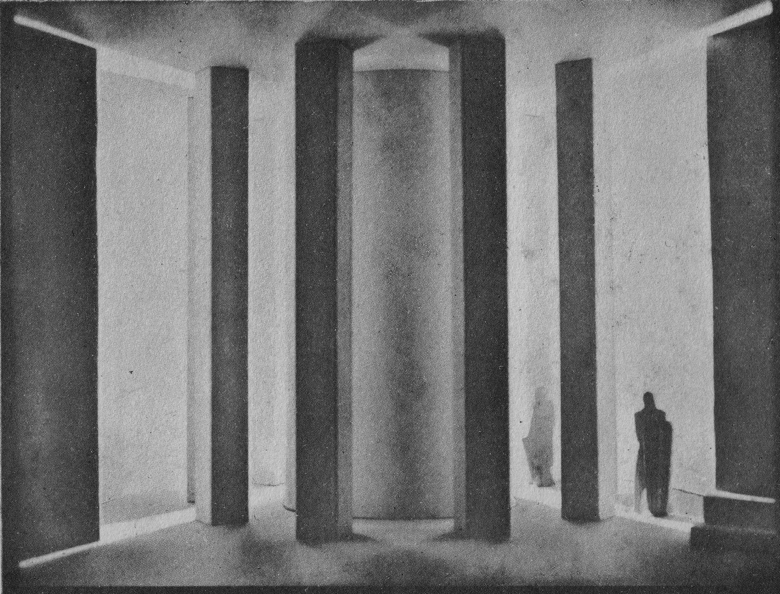

Photograph of a model stage setting by Edward Gordon Craig for a scene in Hamlet, 1912.

